EXPT NO: 1 B)  DATE: | GRAPHICAL METHOD

AIM:
To solve a Linear Programming Problem (LPP) using the graphical method and find the optimal solution using Python.

PROCEDURE:
• Import required libraries: numpy, matplotlib, and scipy.optimize.
• Define the objective function coefficients. Since linprog performs minimization,
convert the maximization problem into minimization by taking negative values.
• Define the inequality constraints in matrix form (A and b).
• Specify the bounds for decision variables (x ≥ 0, y ≥ 0).
• Use the linprog() function to solve the LPP.
• Extract the optimal values of decision variables (x and y).
• Convert the result back to maximization to obtain the optimal value of Z.
• Generate values for x to plot constraint equations.
• Plot all constraint lines on a graph.
• Shade the feasible region that satisfies all constraints.
• Mark the optimal solution point on the graph.
• Label axes, add legend, grid, and display the graph.

PROGRAM 1:

import numpy as np
import matplotlib.pyplot as plt
from scipy.optimize import linprog
# Objective function (maximize Z = 3x + 2y → convert to minimize)
c = [-3, -2]
# Inequality constraints (Ax ≤ b)
A = [
[1, 1], # x + y ≤ 4
[0, 1], # y ≤ 3
[1, 0] # x ≤ 2
]
b = [4, 3, 2]
# Bounds for x and y
x_bounds = (0, None)
y_bounds = (0, None)
# Solve using linprog
res = linprog(c, A_ub=A, b_ub=b, bounds=[x_bounds, y_bounds], method='highs')
# Extract solution
x_opt, y_opt = res.x
z_opt = -res.fun # Convert back to maximization
print(f"Optimal solution: x = {x_opt}, y = {y_opt}, Z = {z_opt}")

# Plotting
x = np.linspace(0, 5, 400)
y1 = 4 - x
y2 = np.ones_like(x) * 3
y3 = np.ones_like(x) * 2
plt.figure(figsize=(8, 8))
plt.plot(x, y1, label='x + y ≤ 4')
plt.plot(x, y2, label='y ≤ 3')
plt.plot(y3, x, label='x ≤ 2')
plt.fill_between(x, np.minimum(y1, y2), where=(x <= 2), color='grey', alpha=0.5)
plt.plot(x_opt, y_opt, 'ro', label='Optimal Solution')

plt.xlim(0, 5)
plt.ylim(0, 5)
plt.xlabel('x')
plt.ylabel('y')
plt.title('Graphical Solution of LPP')
plt.legend()
plt.grid(True)

plt.show()

OUTPUT:

Optimal solution: x = 2.0, y = 2.0, Z = 10.0
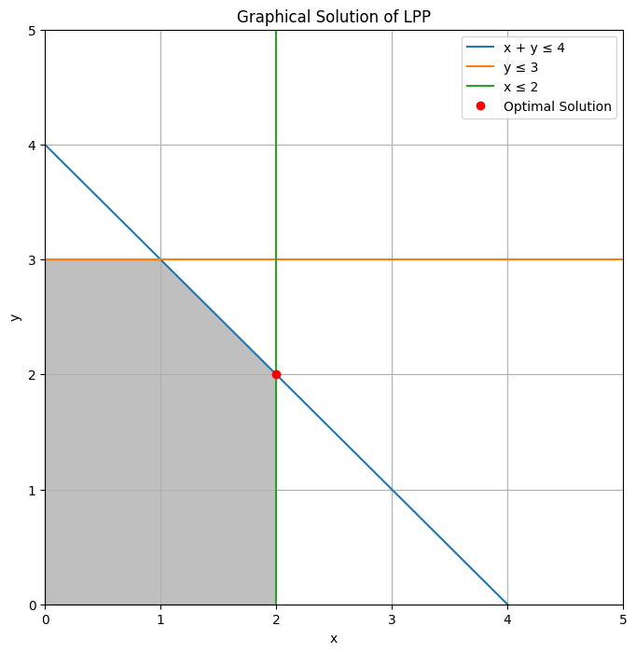

PROBLEM 2:

import numpy as np
import matplotlib.pyplot as plt
from scipy.optimize import linprog
# Objective function (maximize Z = 5x + 4y)
c = [-5, -4]
# Constraints
A = [
[2, 1], # 2x + y ≤ 10
[1, 2] # x + 2y ≤ 8
]
b = [10, 8]
# Bounds
x_bounds = (0, None)
y_bounds = (0, None)
# Solve
res = linprog(c, A_ub=A, b_ub=b, bounds=[x_bounds, y_bounds], method='highs')
x_opt, y_opt = res.x
z_opt = -res.fun
print(f"Optimal solution: x = {x_opt}, y = {y_opt}, Z = {z_opt}")
# Plot
x = np.linspace(0, 10, 400)
y1 = (10 - 2*x)
y2 = (8 - x) / 2
plt.figure(figsize=(8, 8))
plt.plot(x, y1, label='2x + y ≤ 10')
plt.plot(x, y2, label='x + 2y ≤ 8')
plt.fill_between(x, np.minimum(y1, y2), where=(y1 >= 0) & (y2 >= 0), alpha=0.3)
plt.plot(x_opt, y_opt, 'ro', label='Optimal Solution')
plt.xlim(0, 10)
plt.ylim(0, 10)
plt.xlabel('x')
plt.ylabel('y')
plt.title('Graphical Solution (Example 2)')
plt.legend()
plt.grid(True)

plt.show()
OUTPUT:

Optimal solution: x = 4.0, y = 2.0, Z = 28.0
